**P1 B: Perform Conditional Formatting on dataset using various criteria**

1. Create dataset
2. Calculate totals of each row
3. Calculate total of total column -> home>autosum at top right
4. Calculate percentage using “=Cn/$C$10” where n is variable
5. Go to home>% to convert decimal to percentage value
6. highlight cells with duplicate values -> home>conditional formatting>highlight cell rules
7. highlight cells with greater values -> home>conditional formatting>highlight cell rules
8. 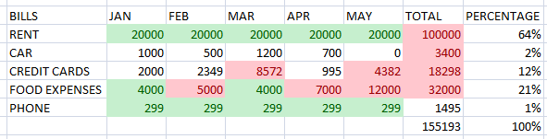
9. Color scale percentage using 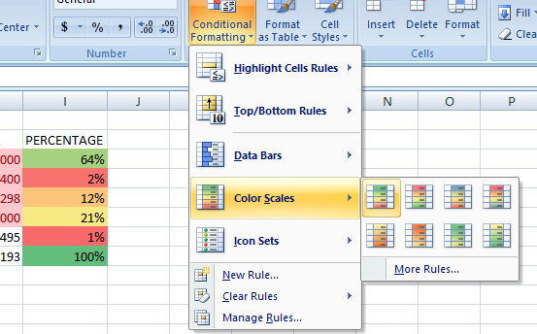
10. Create percentage bargraphs 